
Monmouth Wyedean Circle 374

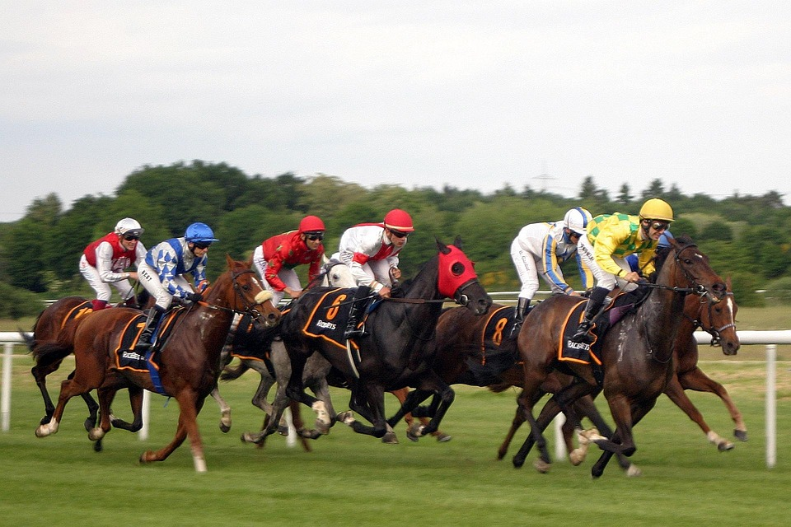

PROVINCE 12 “GRAND NATIONAL” RACE NIGHT
Saturday, 18 April 2026
Whitchurch & Ganarew Memorial Hall, Old Monmouth Road, Whitchurch, HR9 6DJ.
Doors open 7:00pm. First Race 7:30pm prompt.
Bring your own food and drinks.
£5 admission. Sponsor a Horse or a Jockey £5.
Please come! If you can’t come, please sponsor! All proceeds to:
Reach Out Monmouth & St. David’s Hospice

